IFG Explore 3rd Year

An Eight week programme

Term One Berenstain Bears
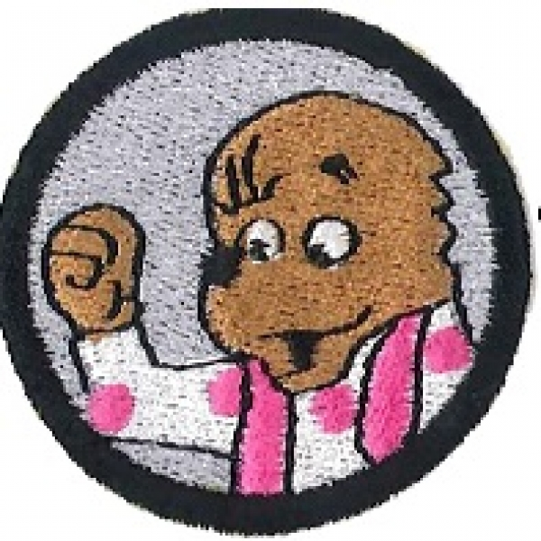
Aim:
To learn a godly attribute by reading a different Berenstain Bear story each week.

Stan and Jan Berenstain have written over 100 stories about this loveable bear family. Mike Berenstain has continued the family writing tradition and through the stories introduces children to Godly attributes. They can be purchased from many bookshops including “The Bible Society” and “The Warehouse”. They are produced by Random House Publishers.
Some suggested titles are:
- The Berenstain Bears Show God’s Love (5 books in one)
- The Berenstain Bears Follow God’s Word (5 books in one)
- The Berenstain Bears Kindness Counts
- The Berenstain Bears and the Joy of Giving
- The Berenstain Bears and A Job Well Done
- The Berenstain Bears and the Gift of Courage
- The Berenstain Bears and the Truth
- The Berenstain Bears Forget their Manners

It is up to you to choose which stories you want to use. The titles above are only a few of the many available. Some of you will already have some so use the ones you have. If you need to purchase more I would suggest you choose “Follow God’s Word” and “Show God’s Love”. Both of these include 5 stories and can be purchased from “The Bible Society“for $24.99. The singles are $6.99 a copy (price October 2011)

There is an Interactive Berenstain Bears website which may be useful http://pbskids.org/berenstainbears/games/index.html

Games for this unit:
Use games that the girls are already familiar with or refer to the games book. Where possible adapt the games used to Bears. E.g. If using teams use the names of the Berenstain Bears.

Some bear rhymes

Teddy Bear, Teddy Bear
Teddy Bear, Teddy Bear, turn around,
Teddy Bear, Teddy Bear, touch the ground
Teddy Bear, Teddy Bear, show your shoe
Teddy Bear, Teddy Bear, that will do!
Teddy Bear, Teddy Bear, go upstairs-
Teddy Bear, Teddy Bear, say your prayers-
Teddy Bear, Teddy Bear, turn out the lights-
Teddy Bear, Teddy Bear, say good-night!
This Little Bear
This little bear has a fur suit. (thumb)
This little bear acts very cute (pointer finger)
This little bear is bold and cross. (middle finger)
This little bear says, "You're not boss." (ring finger)
This little bear likes bacon and honey. (little finger)
But he can't buy them, he has no money.
The Teddy Bear Dance
Tune: Twinkle Twinkle Little Star
Pick your bear up off the ground
And go dancing all around
Hold him high and hold him low
Twirl him fast and twirl him slow
'Round and 'round and 'round you go
When you dance, don’t let him go.
Five Little Bears
Five little bears were sitting on the ground.
Five little bears made a deep growling sound: Grrrrr!
The first one said, “Let’s have a look around."
The second one said, "I feel rather funny!"
The third one said, "I think I smell honey."
The fourth one said, "Shall we climb up the tree?"
The fifth one said, "Look out! There's a bee!"
So the five little bears went back to their play,
And decided to wait till the bees flew away.

IFG Explore 3rd Year

Term One Week One Berenstain Bears Outdoor Activities

Aims:
To learn a godly attribute by reading a different Berenstain Bear story.

Objectives:
- To enjoy playing games
- To welcome any new girls
- To make a bear mask
- To have a bear supper

Equipment Needed:
- Equipment for games chosen
- Card for masks
- Crayons
- Scissors
- String or hat elastic for masks
- Tiny teddy biscuits and juice for supper

Preparation:
Make sure you have all necessary equipment for the games chosen

Pre Setup:
Enlarge and print off the mask template for each girl. Setup craft tables prior to the girls arriving.

SetUp:
Commence the formal part of the evening with roll call etc.

Devotions:
Berenstain Bear story

Prayer:

Activity Session:
Play several games that can be related to bears or animals.

Teaching/Activity Session:
Make bear masks. See template below

Notices and Home Time:
The girls will need to take home a notice telling the parents that they are going off site next week for a busk walk.
End evening with a prayer

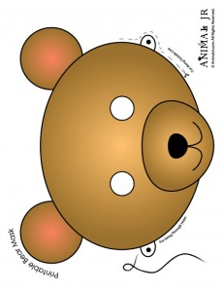  Brown Bear Mask to Print | 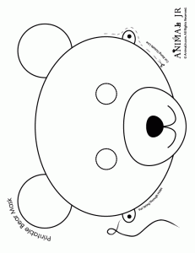  Bear Mask to Print and Color

IFG Explore 3rd Year

Term One Week Two Berenstain Bears Outdoor Activities

Aims:
To learn a godly attribute by reading a different Berenstain Bear story.

Objectives:
- To welcome any new girls
- To go on a Bear Hunt (bush walk)

Equipment Needed:
- Equipment for games chosen
- Bear Hunt lists
- A plastic bag for each group to put the items they find in.
- Tiny teddy biscuits and water for the girls to drink.

Preparation:
Make sure you have arranged enough transport to get the girls to the venue. Alternately you can meet at the bush walk venue.
Make sure you have all necessary equipment for the games chosen and the Bear Hunt.

SetUp:
Commence the formal part of the evening with roll call etc.

Devotions:
Berenstain Bear story

Prayer:

Teaching/Activity Session:
Go on a bush walk. Divide the girls into small groups with an adult. Give each group a list of things the girls need to find while walking.
After the walk give the girls a drink of water and some tiny teddy biscuits

If there is still time to spare they can play several games.

Notices and Home Time:
The girls will need a notice telling their parents they need to bring their teddys next week.
End evening with a prayer

Suggested items for the Bear Hunt list

- Leaf
- Twig
- Feather
- Stone
- Flower
- Piece of paper
- Items the leaders have hidden earlier

The Bear Hunt Song

Bottom of Form
(Leader)
We're going on a bear hunt!
(Group)
We're going on a bear hunt!
We're gonna catch a big one!
We're gonna catch a big one!
I'm not afraid!
I'm not afraid!
Are you?
Are you?
Not me!
Not me!
Here comes the gate
(Group Echos)
Now we're on a bear hunt
We're gonna catch a big one
I'm not afraid
Are you? " " Not me!
We're coming to a tall mountain
It sure is high
It sure is wide
Let's climb up it
Well, there's nothing over there
Nothing over there
Nothing back there
Hey! Wait! I think I see something
Quick! Everybody run down!
We're going on a bear hunt!
We're going on a bear hunt!
We're gonna catch a big one!
We're gonna catch a big one!
I'm not afraid!
I'm not afraid!
Are you?
Are you?
Not me!
Not me!
We're going thru the tall grass
We're going thru the short grass
Hey! Look! There's a little tree
Well, let's shinny on up it
Whoa! It gets a little skinny up here at the top
See anything over that way?
Anything over that way?, Uh, oh!,
Oh, no! Whoa! Agh! Let’s get down!
We're going on a bear hunt!
We're going on a bear hunt!
We're gonna catch a big one!
We're gonna catch a big one!
I'm not afraid!
I'm not afraid!
Are you?
Are you?
Not me!
Not me!
Oh, no! " "
It's a big puddle of mud
Can't go around it
Gotta go right thru it
Yeuk!
Well, let's go.
Squish, Sqwish, Blaaahh.
We're going on a bear hunt!
We're going on a bear hunt!
We're gonna catch a big one!
We're gonna catch a big one!
I'm not afraid!
I'm not afraid!
Are you?
Are you?
Not me!
Not me!
We're coming to a wide river
And there's no bridge going over it
No tunnel going under it
It's just plain old water
And we're gonna have to swim
All right, dive in!
Start swimming
Do the back stroke
Do the side stroke
Do the doggie paddle
Try the little cat paddle
OK Jump out, shake yourself off
We're going on a bear hunt!
We're going on a bear hunt!
We're gonna catch a big one!
We're gonna catch a big one!
I'm not afraid!
I'm not afraid!
Are you?
Are you?
Not me!
Not me!
Shhh, it's a cave
Looks like the kind of cave that B-bears live in
I don't know if I want to go in there
You think we oughta go in?
Are you nuts?
There's probably a bear in there
All right I'll go in, You stay here,
And if I find a bear, I'll come out and get you
And we'll all go in and grab him together
Now, quiet, don't make a sound while I'm in that cave,
Cuz if you wake him up, I'll be in trouble
Bears are awful ornery when they first wake up, you know
OK, I'm going on in
Oooo, It's dark in here
It's really dark in here
I can't see a thing
Agh, there's spiders webs
Ooo, what was that???
What's this??.... it's soft, uh oh,it's kind of fuzzy
Ahg!!!!!!!!! Run! Everybody run!!
I saw a bear!!!!
Jump in the water! Swim fast!!
Do the backstroke!
The sidestroke, the doggie paddle
Jump out of the water
Run through the mud!
Forget the tree!!
Go through the tall grass
The short grass
Quick! Go up the mountain
Down the other side
Go thru the gate
Into the house, under the bed
Under the pillow
Hide!!!!!
Uh, it's awful quiet around here
I'm not afraid
I'm not afraid
Are you?
Are you?

IFG Explore 3rd Year

Term One Week Three Berenstain Bears Outdoor Activities

Aims:
To learn a godly attribute by reading a different Berenstain Bear story.

Objectives:
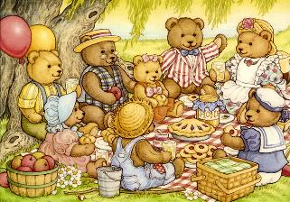
- To welcome any new girls
- To have a Teddy bears picnic

Equipment Needed:
- Teddies
- Picnic blankets
- Picnic food
- Equipment for games chosen
- Teddy Bears Picnic CD (or someone who can play it for you)

Preparation:
Make sure you have all necessary equipment for the games chosen

Pre Setup:
Set the picnic area up before the girls arrive

SetUp:
Commence the formal part of the evening with roll call etc.

Devotions:
Berenstain Bear story

Prayer:

Activity Session:
- Play good old fashioned picnic games like egg and spoon, sack races, three legged run and the wheelbarrow race.
For new twists on old favourites try:
- Pin the Nose (or the Bow Tie) on the Teddy Bear
- Pass the Parcel wrapped in picnic blankets or table cloths, rather than paper.
- Musical Picnic Stools

If possible include the bears in the games.

Finish with the picnic food. And sing the Teddy Bears Picnic song

Notices and Home Time:
End evening with a prayer

WORDS TO THE TEDDY BEAR's PICNIC SONG
If you go out in the woods today
you’re sure of a big surprise.
If you go out in the woods today
you’d better go in disguise.
For every bear that ever there was
will gather there for certain, because
Today's the day the teddy bears have their picnic.
Picnic time for teddy bears,
The little teddy bears are having a lovely time today.
Watch them, catch them unawares,
And see them picnic on their holiday.
See them gaily dance about.
They love to play and shout.
And never have any cares.
At six o'clock their mommies and daddies
will take them home to bed
because they're tired little teddy bears.
If you go out in the woods today,
You'd better not go alone.
It's lovely out in the woods today,
But safer to stay at home.
For every bear that ever there was
Will gather there for certain, because
Today's the day the teddy bears have their picnic
CHORUS
Every teddy bear, that's been good
Is sure of a treat today
There's lots of wonderful things to eat
And wonderful games to play
Beneath the trees, where nobody sees
They'll hide and seek as long as they please
Today's the day the teddy bears have their picnic
CHORUS

IFG Explore 3rd Year

Term One Week Four Berenstain Bears Craft

Aims:
To learn a godly attribute by reading a different Berenstain Bear story.

Objectives:
- To enjoy playing games
- To make a Pom Pom bear

Equipment Needed:
- Equipment for games chosen
- Materials to make Pom Pom Bears

Preparation:
Make sure you have all necessary equipment for the games chosen
Collect/purchase all the materials required to make the Pom Pom Bears

Pre Setup:
Set up the craft on tables before the girls arrive

SetUp:
Commence the formal part of the evening with roll call etc.

Devotions:
Berenstain Bear story

Prayer:

Activity Session:
Play several games that can be related to bears or animals.

Teaching/Activity Session:
Make a Pom Pom bear. Instructions are below.

Notices and Home Time:
End evening with a prayer
If the girls are going off site for the next three weeks the parents will need to be told the details.

POM POM TEDDY BEARS

You will need:
9 Pom Poms in 3 different sizes (like shown here)

1 for the Body, 1 for the Head and 7 for arms, legs & face
1 small black bead
2 googly eyes
White Glue – need a strong quick drying glue – could use glue gun
Toothpick
Wax Paper
Optional: Ribbon, Small Silk Flowers


Glue the head pom pom (medium size) to the body pom pom (large size)
. 

Next put glue on 2 of the smaller pom poms. If you put a dab of glue on a piece of wax paper and slightly press the pom pom into the glue, it won't be as messy. Then press the pom poms onto the body pom pom. Set them so the bear can sit without falling over.


Next glue the 2 arms onto the body. I like to use a toothpick to pick up a little extra glue to put on the arm pom poms (after putting them on to the body), I put the glue up near the back-top area... so that the arms will also be glued to the head pom pom.


Here is the fun part... because this is where your Pom Pom Teddy Bear starts to take on his/her own character! Glue on the muzzle (small pom pom). Then glue on the 2 googly eyes. Next glue on the black bead for your teddy bear's nose.


Next glue on the 2 ears (small pom poms). Set them right up on the top of your teddy bear's head. To finish up your Teddy Bear, you can add tiny bows, small silk flowers and other fancy items! These are a "hit" at school sales!

IFG Explore 3rd Year

Term One Weeks Five - Seven Berenstain Bears Gym Activities

For the next three weeks the girls will be involved in various gym activities. There are several different ways you can do this. It would be good if you use a different facility each week.
Suggestions are:
- Some of you may meet in facilities that have equipment available the girls can use (eg low vaulting horse, low beams to walk along, mats for rolling on, hoops, balls etc).
- Visit a variety of local playgrounds with different types of activities (eg monkey bars, climbing walls, rope or net climbing, slides, swings, poles to slide down)
- Visit a local gym club and use facilities there – they may also supply instructors.
- Visit a local fitness gym and use their facilities – they may also supply instructors.
If going off site the parents will need to be told the arrangements before these three weeks are commenced.

Aims:
To learn a godly attribute by reading a different Berenstain Bear story.

Objectives:
- To have fun trying some basic gymnastics activities

Equipment Needed:
This will depend of the option chosen each week

Preparation:
Make sure you have completed the offsite and RAMS forms and that you have sufficient adult supervision.
Make sure you have all necessary equipment for the activities chosen.

Pre Setup:
Make sure any equipment is set out before the girls arrive.

SetUp:
Commence the formal part of the evening with roll call etc.

Devotions:
Berenstain Bear story
Prayer:

Teaching/Activity Session:
Sit the girls down and explain the activities including any rules before beginning.
Depending on how many girls you have you may need to divide them into several groups. Make sure you have an adult with each group.
Work out how many activities you have and divide the time so that the girls have the same amount of time at each activity. When it is time to change activity blow a whistle so they all move together.

Notices and Home Time
End evening with a prayer

IFG Explore 3rd Year

Term One Week Eight Berenstain Bears Zoo/Animal Park Visit and Award Night

Aims:
To learn a godly attribute by reading a different Berenstain Bear story.

Objectives:
- To have fun visiting a local Animal Park.
- To learn some facts about the animals by answering questions.
- To present the girls with their badges earned this term.

Equipment Needed:
- Whistle
- Name tags for the girls

Preparation:
Make sure you have completed the offsite and RAMS forms and that you have sufficient adult supervision.
Print off sheets with questions for the girls to answer as they walk around the zoo/park.

SetUp:
Commence the formal part of the evening with roll call etc.

Devotions:
Berenstain Bear story

Prayer:

Teaching/Activity Session:
Divide the girls into small groups each with an adult. Give each adult the sheet with the questions and a pen to write the answers. Walk around the Park, see the animals and answer the questions.

Notices and Home Time:
End evening by presenting the girls with their badges.

Closing Prayer

